Bank Loan report query document
KPI’s:
Total Loan Applications
select count(id) as total_applications from bank_loan_table ;

Month-To-Date total loan applications
select count(id) as Month_to_Date_total_application
from bank_loan_table where month(issue_date)= (select month(max(issue_date)) from bank_loan_table)
and year(issue_date)=(select year(max(issue_date)) from bank_loan_table)
and issue_date<=(select(max(issue_date)) from bank_loan_table);
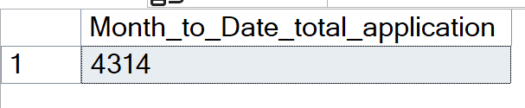
Previous-month-to-date loan applications
select count(id) as previous_month_to_date_total_applications from
bank_loan_table
where month(issue_date)=11 and year(issue_date)=2021;
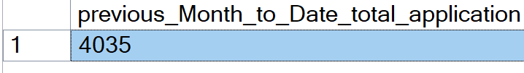
Total_funded_amount
select sum(loan_amount) as total_funded_amount from
bank_loan_table;
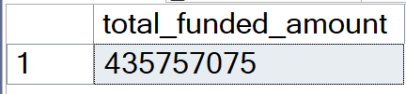
Month-to-date-total-funded-amount
select sum(loan_amount) as month_to_date_total_funded_amount from
bank_loan_table where month(issue_date)= (select month(max(issue_date)) from bank_loan_table)
and year(issue_date)=(select year(max(issue_date)) from bank_loan_table)
and issue_date<= (select max(issue_date) from bank_loan_table);
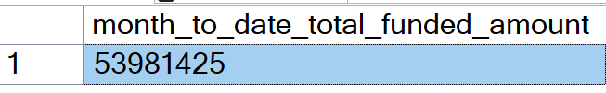
Previous-Month-to-date-total-funded-amount
select sum(loan_amount) as previous_month_to_date_total_funded_amount from
bank_loan_table
where month(issue_date)=11 and year(issue_date)=2021;
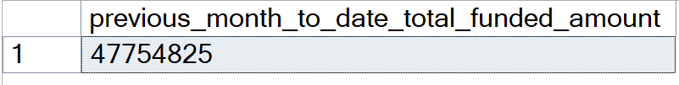

Total_amount_received
select sum(total_payment) as Total_amont_received
from bank_loan_table;
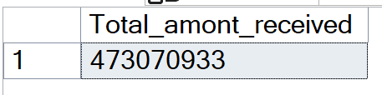
Month-to-date-total-amount-received
select sum(loan_amount) as month_to_date_total_funded_amount from
bank_loan_table where month(issue_date)= (select month(max(issue_date)) from bank_loan_table)
and year(issue_date)=(select year(max(issue_date)) from bank_loan_table)
and issue_date<= (select max(issue_date) from bank_loan_table);
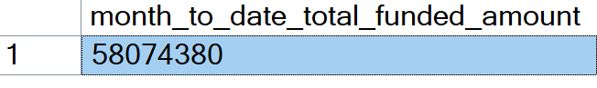
Previous- Month-to-date-total-amount-received
select sum(total_payment) as previous_month_to_date_total_amount_received
from
bank_loan_table
where month(issue_date)=11 and year(issue_date)=2021;
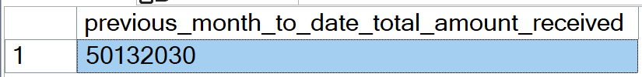
Average Interest Rate
Select avg(int_rate)*100 as avg_interest_rate
from bank_loan_table;
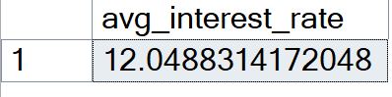
Month-to-date-average-interest
select avg(int_rate)*100 as month_to_date_avg_interest_rate from
bank_loan_table where month(issue_date)= (select month(max(issue_date)) from bank_loan_table)
and year(issue_date)=(select year(max(issue_date)) from bank_loan_table)
and issue_date<= (select max(issue_date) from bank_loan_table);
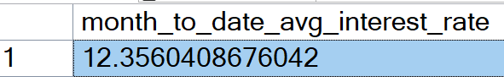
Previous-month-to-date-average-interest
select sum(total_payment) as previous_month_to_date_total_amount_received
from
bank_loan_table
where month(issue_date)=11 and year(issue_date)=2021;
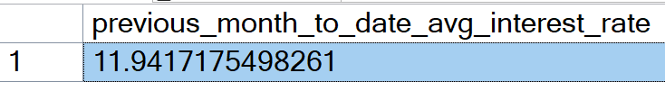
Average Debt-to-income Ratio:
SELECT AVG(dti)*100 AS Avg_DTI FROM bank_loan_table
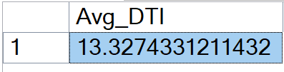
Month-to-date Average DTI
select avg(dti)*100 as month_to_date_avg_dti from
bank_loan_table where month(issue_date)= (select month(max(issue_date)) from bank_loan_table)
and year(issue_date)=(select year(max(issue_date)) from bank_loan_table)
and issue_date<= (select max(issue_date) from bank_loan_table);
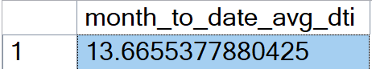
Previous month to date average DTI
SELECT AVG(dti)*100 AS PMTD_Avg_DTI FROM bank_loan_table
WHERE MONTH(issue_date) = 11
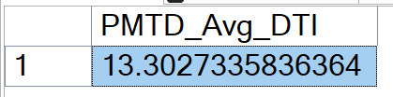

GOOD LOAN ISSUED
Good Loan Percentage
select (count(case when loan_status='Fully Paid' or loan_status='Current'then id end)*100)
/ count(id) as Good_loan_percentage
from bank_loan_table
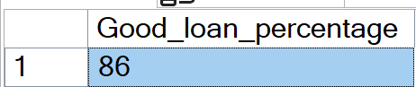
Good loan application
select count(id) as good_loan_applications
from bank_loan_table
where loan_status='Fully Paid' or loan_status='Current'
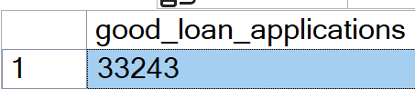
Good loan funded Amount
select sum(loan_amount) as good_loan_funded_amount
from bank_loan_table
where loan_status='Fully Paid' or loan_status='Current'
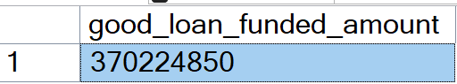
Good Loan received Amount
select sum(total_payment) as good_loan_received_amount
from bank_loan_table
where loan_status='Fully Paid' or loan_status='Current'
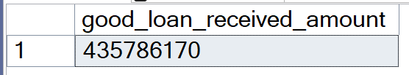
BAD LOAN
Bad loan Percentage
select (count(case when loan_status='Charged Off' then id end)*100.0)/
count(id) as bad_loan_percentage
from bank_loan_table
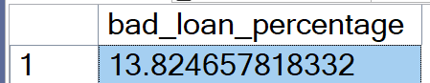
Bad loan Application
select count(id) as bad_loan_application
from bank_loan_table
where loan_status='Charged Off';

Bad loan funded amount
select sum(loan_amount) as bad_loan_Funded_amount
from bank_loan_table
where loan_status='Charged Off';
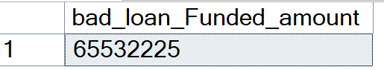
Bad loan received Amount
select sum(total_payment) as bad_loan_amount_received
from bank_loan_table
where loan_status='Charged Off';
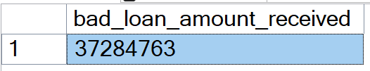
LOAN STATUS
select loan_status,
count(id) as total_loan_application,
sum(total_payment) as total_amount_received,
sum(loan_amount) as total_funded_amount,
avg(int_rate * 100) as Interest_Rate,
avg(dti * 100) as DTI
from bank_loan_table
group by loan_status
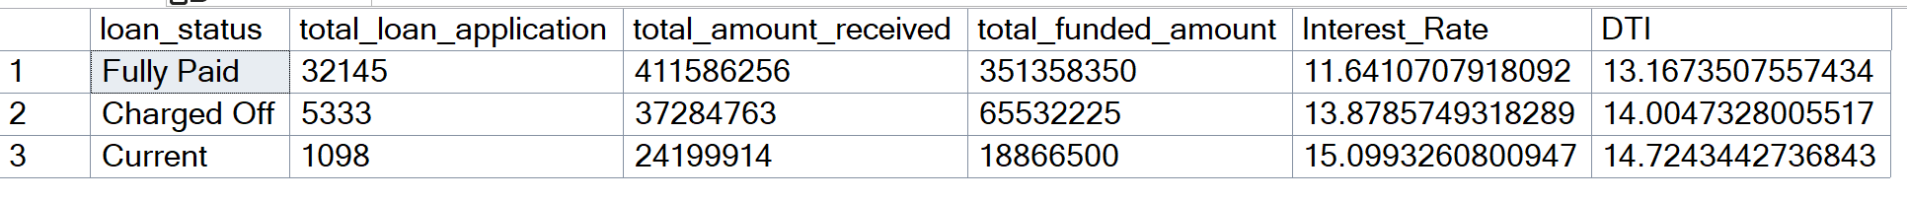

BANK LOAN REPORT
MONTH
select DATENAME(month,issue_date) as month_name,
count(id) as total_loan_application,
sum(loan_amount) as total_funded_amount,
sum(total_payment) as total_amount_received
from bank_loan_table
group by month(issue_date),DATENAME(month,issue_date)
order by month(issue_date);

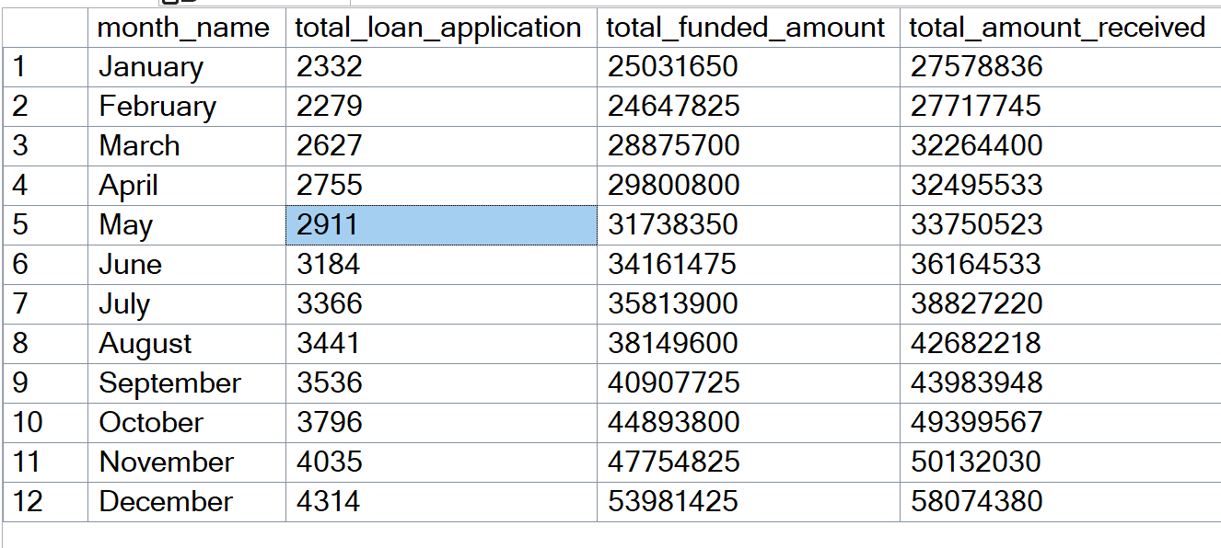

STATE
select address_state,
count(id) as total_loan_application,
sum(loan_amount) as total_funded_amount,
sum(total_payment) as total_amount_received
from bank_loan_table
group by address_state
order by address_state

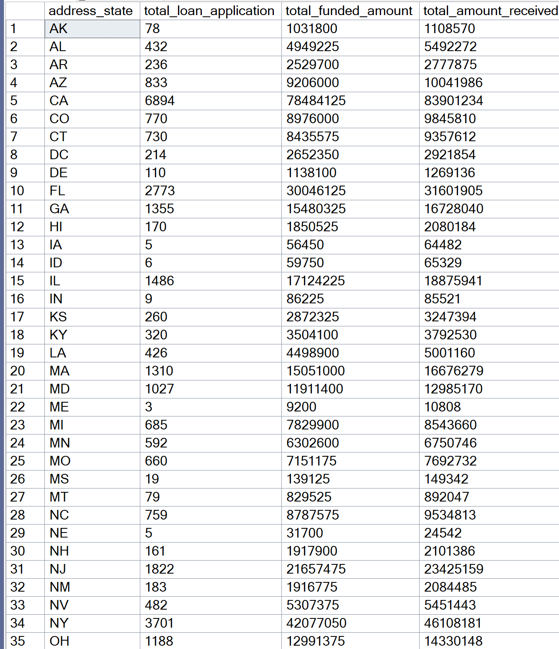
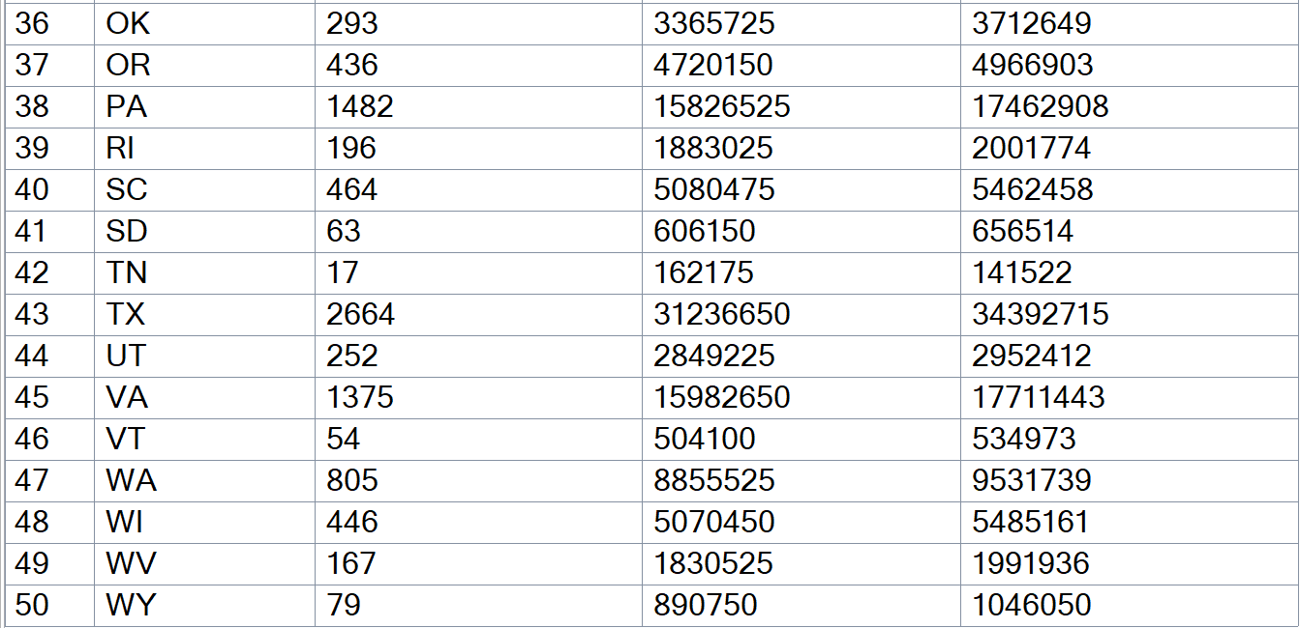
TERM WISE ANALYSIS
select term
,sum(loan_amount) as total_funded_amount,
sum(total_payment) as total_amount_received
from bank_loan_table
group by term
order by term

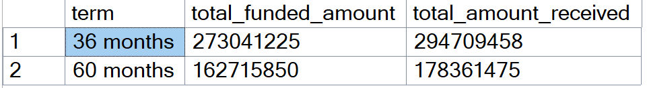

EMPLOYEE LENGTH

select emp_length
,sum(loan_amount) as total_funded_amount,
sum(total_payment) as total_amount_received
from bank_loan_table
group by emp_length
order by emp_length
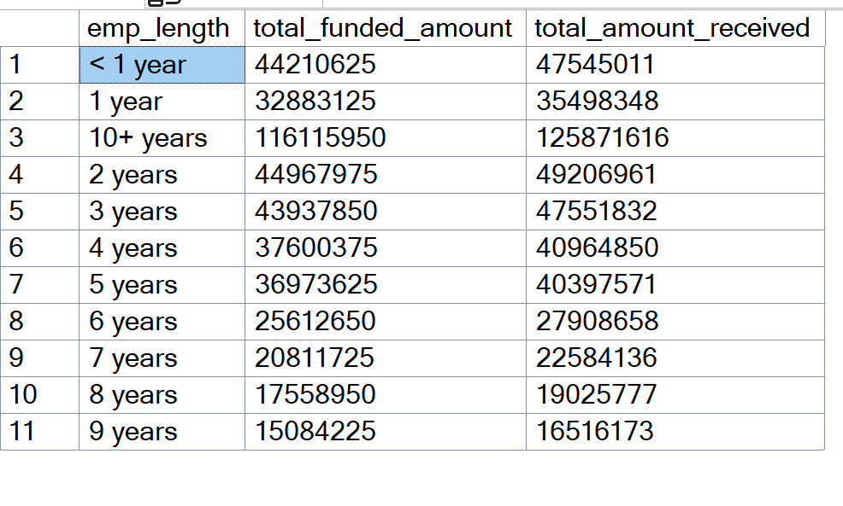
Loan Purpose
select purpose,
count(id) as total_loan_applications
,sum(loan_amount) as total_funded_amount,
sum(total_payment) as total_amount_received
from bank_loan_table
group by purpose
order by count(id)
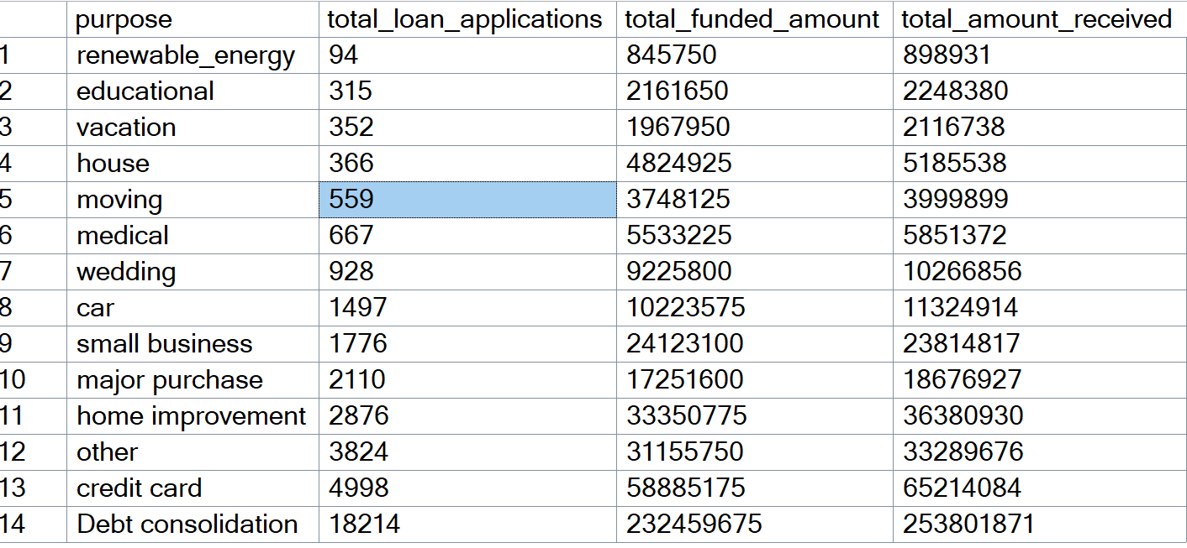

HOME OWNERSHIP
select home_ownership,
count(id) as total_loan_applications
,sum(loan_amount) as total_funded_amount,
sum(total_payment) as total_amount_received
from bank_loan_table
group by home_ownership
order by count(id)
